

**Everyone Can Be a Poet**

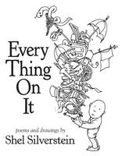

**Students will learn about the different types of poetry and how to create their own poems through this unit.**  
  
**Some of our favorite poets are: Shel Silverstein and Jack Prelutsky.**

Picture

Picture

|  |  |
| --- | --- |
| [Picture](http://shelsilverstein.com/indexSite.html)  Shel Silverstein's Website | [Picture](http://www.jackprelutsky.com/)  Jack Prelutsky's Website |

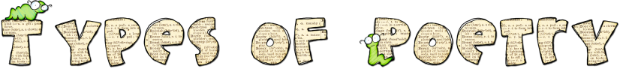



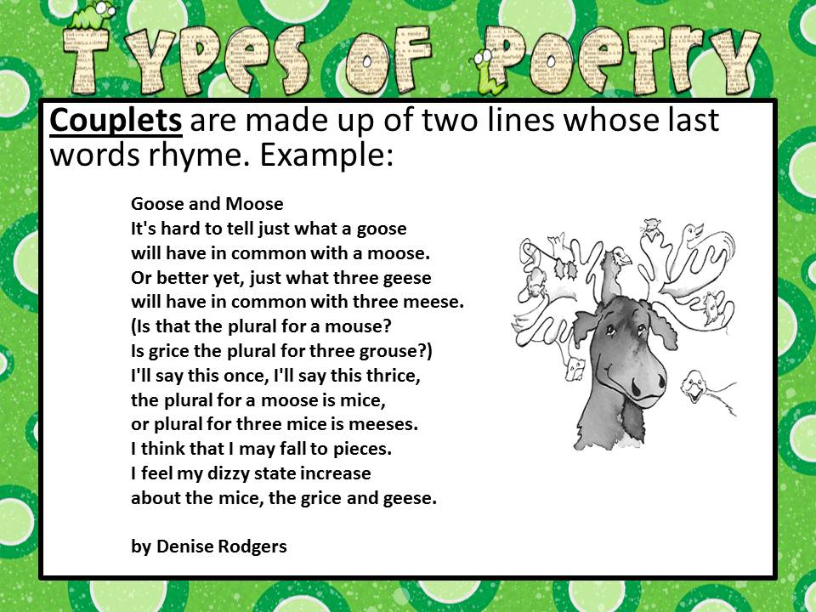

|  |  |
| --- | --- |
| [Picture](http://www.gigglepoetry.com/poetryclass/sick.html)  Giggle Poetry - Couplet |  |



|  |  |
| --- | --- |
| [Picture](http://mrswarnerarlington.weebly.com/uploads/6/9/0/0/6900648/cinquainpoem1byjudybonzer.jpeg)  [Picture](http://teacher.scholastic.com/writewit/poetry/flash_pie.htm)  Scholastic - Cinquain | [Picture](http://pbskids.org/arthur/games/poetry/cinquain.html)  Arthur - Fern's Poetry Club - Cinquain |



|  |  |
| --- | --- |
| [Picture](http://mrswarnerarlington.weebly.com/uploads/6/9/0/0/6900648/acrosticpoem1byjudybonzer.jpeg)  [Picture](http://www.readwritethink.org/files/resources/interactives/acrostic/)  Read, Write, Think - Acrostic  [Picture](http://www.abcteach.com/directory/basics/writing/poetry/acrostics/)  ABCTeach -Forms for Acrostic Poems |  |



|  |  |
| --- | --- |
| [Picture](http://mrswarnerarlington.weebly.com/uploads/6/9/0/0/6900648/diamantepoem1byjudybonzer.jpeg)  [Picture](http://www.readwritethink.org/files/resources/interactives/diamante/) | [Picture](http://www.franklinlakes.k12.nj.us/famsweb/curriculum/English/diamantepoems/diamante.html)  Mrs. Murphy's Class - Diamante |



|  |  |
| --- | --- |
| [Picture](http://teacher.scholastic.com/writewit/poetry/flash_pie.htm)  Scholastic - Free Verse | [Picture](http://pbskids.org/arthur/games/poetry/free_verse.html)  Arthur - Fern's Poetry Club - Free Verse |



|  |  |
| --- | --- |
| [Picture](http://mrswarnerarlington.weebly.com/uploads/6/9/0/0/6900648/limerickpoem1byjudybonzer.jpeg)  [Picture](http://pbskids.org/arthur/games/poetry/limerick.html)  Arthur - Fern's Poetry Club - Limerick  [Picture](http://teacher.scholastic.com/writewit/poetry/flash_pie.htm)  Scholastic - Limerick  [Picture](http://www.learner.org/teacherslab/math/patterns/limerick/limerick_acttxt.html)  Limerick Factory | [Picture](http://www.channel4learning.com/sites/bookbox/games/limericks/home.htm)  Is It A Limerick? |



|  |  |
| --- | --- |
| [Picture](http://www.readwritethink.org/files/resources/interactives/shape/)  Read, Write, Think - Shape Poem  [Picture](http://www.bbc.co.uk/schools/ks2bitesize/english/reading/poetry/watch.shtml)  BBC Poetry - Melvin & Steven Poetry | Picture  Picture |



|  |  |
| --- | --- |
| [Picture](http://mrswarnerarlington.weebly.com/uploads/6/9/0/0/6900648/haikupoem1byjudybonzer.jpeg)  [Picture](http://teacher.scholastic.com/writewit/poetry/flash_pie.htm)  Scholastic - Haiku  [Picture](http://homepage2.nifty.com/haiku-eg/)  Children's Haiku Garden |  |



|  |  |
| --- | --- |
| [Picture](http://mrswarnerarlington.weebly.com/uploads/6/9/0/0/6900648/colorpoem1byjudybonzer.jpeg)  [Picture](http://mrswarnerarlington.weebly.com/uploads/6/9/0/0/6900648/fivewpoem1byjudybonzer.jpeg) | Picture |



|  |  |
| --- | --- |
| **How to Write a Bio Poem**  [Picture](http://mrswarnerarlington.weebly.com/uploads/6/9/0/0/6900648/biopoem.pdf) |  |

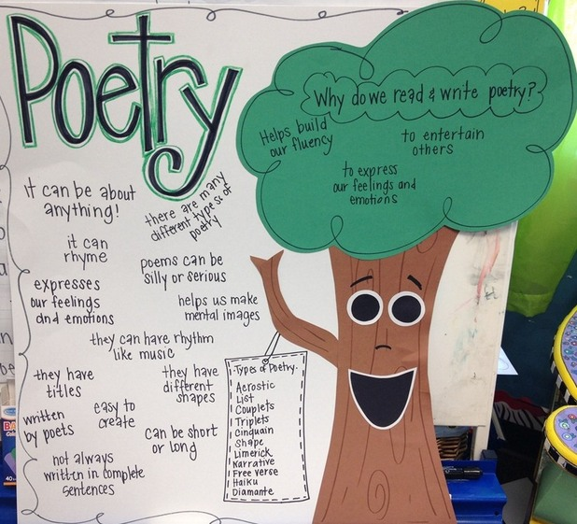

|  |  |
| --- | --- |
| Picture |  |

[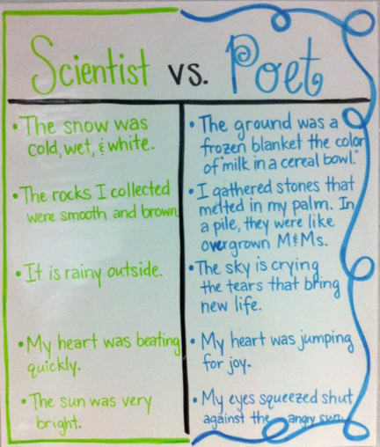](http://mrswarnerarlington.weebly.com/uploads/6/9/0/0/6900648/poet_vs_scientist.png)

**Poetry Tutorial Slideshow**

Picture

|  |
| --- |
| http://mrswarnerarlington.weebly.com/uploads/6/9/0/0/6900648/1342882_orig.jpg  http://mrswarnerarlington.weebly.com/uploads/6/9/0/0/6900648/2114718_orig.jpg  http://mrswarnerarlington.weebly.com/uploads/6/9/0/0/6900648/6295015_orig.jpg  http://mrswarnerarlington.weebly.com/uploads/6/9/0/0/6900648/3257926_orig.jpg  http://mrswarnerarlington.weebly.com/uploads/6/9/0/0/6900648/8213613_orig.jpg  Play  Pause |



**Click on website links below.**

|  |  |
| --- | --- |
| [Picture](http://www.gigglepoetry.com/index.aspx)  Giggle Poetry  [Picture](http://www.rif.org/kids/readingplanet/gamestation/poetrysplatter.htm)  Poetry Splatter  [Picture](http://www.earobics.com/gamegoo/games/wiznpigs/wiznpigs.html)  Wizards and Pigs  [Picture](http://www.zuzu.org/poix.html)  Poetry Examples  [Picture](http://www.rhymezone.com/)  Rhyme Zone - Help with rhyming  [Picture](http://www.rhymer.com/)  Rhyme by: Write Express | [Picture](http://kids.magpogames.com/playonline.cfm)  Kids' Kits Online - Magnetic Poetry  [Picture](http://www.bbc.co.uk/schools/ks2bitesize/english/reading/poetry/watch.shtml)  BBC - Melvin & Steven Poetry  [Picture](http://www.starfall.com/n/level-b/poetry/play.htm?f)  Starfall Poetry  [Picture](http://www.bbc.co.uk/schools/magickey/adventures/creamcake.shtml)  BBC Poetry Games |

[](http://www.funny-poems-for-free.com/index.html)

Funny Poems for Free





